**Sprint 1 - Endurance Design Document**

**April 6, 2023**

**Table of Contents**

**1.** **EXECUTIVE SUMMARY**

1.1 Project Overview

**2.** **PRODUCT/SERVICE DESCRIPTION**

2.1 Product Context

2.2 User Characteristics

2.3 Assumptions

2.4 Constraints

2.5 Dependencies

**3.** **REQUIREMENTS**

3.1 Functional Requirements

**4.** **REQUIREMENTS CONFIRMATION/STAKEHOLDER SIGN-OFF**

**5.** **SYSTEM DESIGN**

5.1 Algorithm

5.2 System Flow

5.3 Program Code

5.4 Program SENSORY Data

5.5 Test Plan

5.6 Task List/Gantt Chart

5.7 Staffing Plan

1. Executive Summary

***1.1*** ***Project Overview***

We are tasked with creating a program for a robot. Within this program, the robot must be able to speak, change colors, and navigate a specified course provided by the professor. Your robot must successfully run the figure eight course 5 times. A path will be laid out on the floor. Your robot must stay within the path provided. Your robot will start and finish in the square provided. Upon finishing, the robot will speak ‘I am the winner’ and flash multicolored lights for 5 seconds. Points will be deducted if your robot strays from the path if it does not go around 5 times, or if it does not finish in the same place it started. Points are deducted if the robot does not light and speak at the start and finish if it collides with anything, or if it does not finish in the square where it started. (You may scale down the course for this sprint if space is an issue)

2. Product/Service Description

In this section, describe the general factors that affect the product and its requirements. This section should contain background information, not state specific requirements (provide the reasons why certain specific requirements are later specified).

***2.1*** ***Product Context***

This product is part of a three-part series. This first part is to show a basic understanding of the material and to express any concerns about the material.

***2.2*** ***User Characteristics***

· Student/faculty/staff/other

· experience

· technical expertise

***2.3*** ***Assumptions***

* Need basic training in working with robots
* Need spacial awareness
* Availability to technology

***2.4*** ***Constraints***

· system resource constraints

· availability of team members

· time to complete project

***2.5*** ***Dependencies***

· Device must be able to run the program

· availability of both team members

3. Requirements

**Priority Definitions**

· Priority 1 – Technology and education required to complete the process. Time Management to complete the project on time.

· Priority 2 – Ability to code and fulfill all requirements.

·Priority 3- User-friendly materials, and little to no experience friendly

***3.1*** ***Functional Requirements***

|  |  |  |  |  |  |
| --- | --- | --- | --- | --- | --- |
| **Req#** | **Requirement** | **Comments** | **Priority** | **Date Rvwd** | **SME Reviewed / Approved** |
| ACCUR_01 | Navigate the figure-eight 5 times | Create an outline for how we are going to complete the project | 1 | 3/30/23 | Approved by both parties |
| ACCUR_02 | Speak a phrase | Input data regarding requirements | 2 | 3/30/23 | Waiting approval |
| ACCUR_03 | Flash multi-colored lights | Create an algorithm for the program that the robot is to complete | 3 | 3/30/23 | approved |

4. Requirements Confirmation/Stakeholder sign-off (Gillian provided the information for this section)

Include documentation of the approval or confirmation of the requirements here. For example

|  |  |  |
| --- | --- | --- |
| **Meeting Date** | **Attendees (name and role)** | **Comments** |
| 04/6/23 | Vaughn | confirmed |
| 04/6/23 | Gillian | confirmed |

5. System Design

***5.1*** ***Algorithm***

* Start Program
* Navigate the figure-eight
* Repeat step two 4 more times
* Stop
* speak “ I am the winner”
* Flash multi-colored lights for 5 seconds
* End program

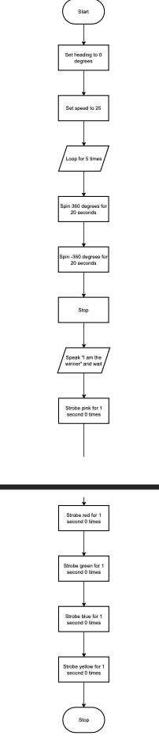

***5.2*** ***System Flow (Gillian provided the information for this section)***

Develop a flowchart (and show here) that accurately depicts how your software application will act to fulfill the algorithm

***5.3*** ***Program Code***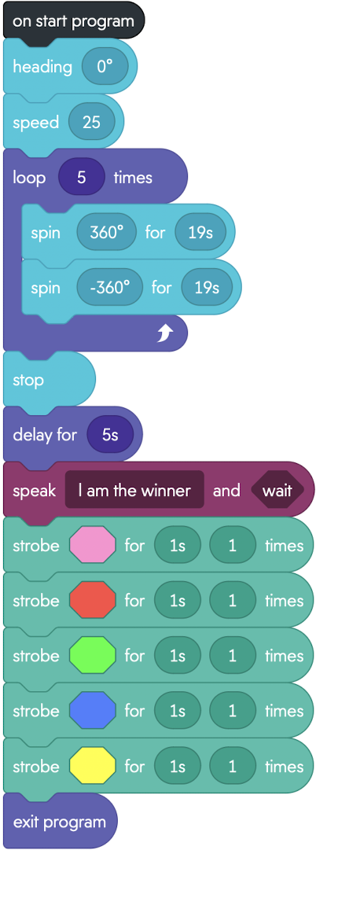

***5.4*** ***Program sensory Data***

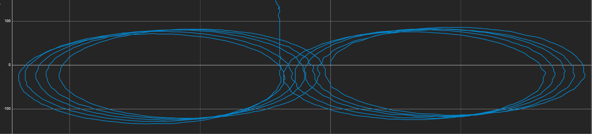

***5.5*** ***Test Plan***

|  |  |  |  |  |  |
| --- | --- | --- | --- | --- | --- |
| **Reason for Test Case** | **Test Date** | **Expected Output** | **Observed Output** | **Staff Name** | **Pass/Fail** |
| Trial 1 | 4/6/23 | Performs the desired course | Performed the course, but not on target | Vaughn | Fail |
| Trial 2 | 4/6/23 | Performs the desired course | Performed the course, but not on target | Vaughn | fail |
| Trial 3 | 4/6/23 | Performs the desired course | Performed the course, but not on target | Vaughn | Fail |
| Trial 4 | 4/6/23 | Performs the desired course | Performed the course, but not on target | Vaughn | Fail |
| Trial 5 | 4/6/23 | Performs the desired course | Performed the course, but not on target | Vaughn | Fail |
| Trial 6 | 4/6/23 | Performs the desired course | Performed the course, but not on target | Vaughn | Fail |
| Trial 7 | 4/6/23 | Performs the desired course | Performed the course, but not on target | Vaughn | Fail |
| Trial 8 | 4/6/23 | Performs the desired course | Performs the desired course | Vaughn | Pass |

***5.6*** ***Task List/Gantt Chart***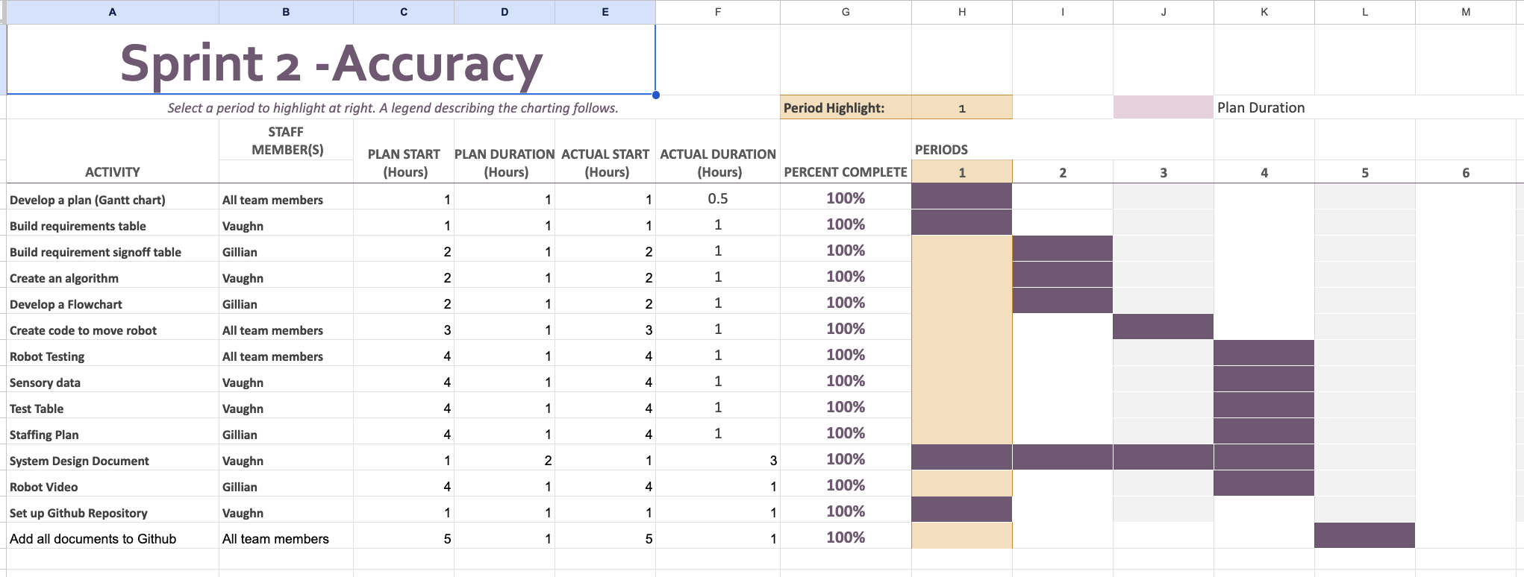

***5.7*** ***Staffing Plan (Gillian provided the information for this section)***

Insert a chart/table that depicts the roles and responsibilities of each team member that worked on this project

|  |  |  |  |
| --- | --- | --- | --- |
| Name | Role | Responsibility | Reports To |
| Vaughn/Gillian | Develop a plan (Gantt chart) | Develop a plan (Gantt chart) | Vaughn/Gillian |
| Vaughn | Build requirements table | Build requirements table | Vaughn/Gillian |
| Gillian | Build requirement signoff table | Build requirement signoff table | Vaughn/Gillian |
| Vaughn | Create an algorithm | Create an algorithm | Vaughn/Gillian |
| Gillian | Develop a Flowchart | Develop a Flowchart | Vaughn/Gillian |
| Vaughn/Gillian | Create code to move robot | Create code to move robot | Vaughn/Gillian |
| Vaughn/Gillian | Robot Testing |  | Vaughn/Gillian |
| Vaughn | Sensory data | Sensory data | Vaughn/Gillian |
| Vaughn | Test Table | Test Table | Vaughn/Gillian |
| Gillian | Staffing Plan | Staffing Plan | Vaughn/Gillian |
| Gillian | Robot Video | Robot Video | Vaughn/Gillian |
| Vaughn | Set up Github Repository | Set up Github Repository | Vaughn/Gillian |
| Vaughn/Gillian | Add all documents to Github | Add all documents to Github | Vaughn/Gillian |

Video:

<https://photos.app.goo.gl/uYYc9c1tGcQpZduv8>

<https://live365monmouth-my.sharepoint.com/:u:/g/personal/s1337217_monmouth_edu/EcjDolmtLANLkcESZKPLGD4BLyMe6JgvjettqNZkV5X22Q?e=AOMbBs>